**Project Design Phase-II**

**Data Flow Diagram & User Stories**

|  |  |
| --- | --- |
| Date | 03 October 2023 |
| Team ID | IRevolution : A Data-Driven Exploration of Apple’s IPhone Impact in India |
| Project Name | Project - F2EAD90353DC960A00D44BB6356F1E94 |
| Maximum Marks | 4 Marks |

**Data Flow Diagrams:**

A Data Flow Diagram (DFD) is a traditional visual representation of the information flows within a system. A neat and clear DFD can depict the right amount of the system requirement graphically. It shows how data enters and leaves the system, what changes the information, and where data is stored.

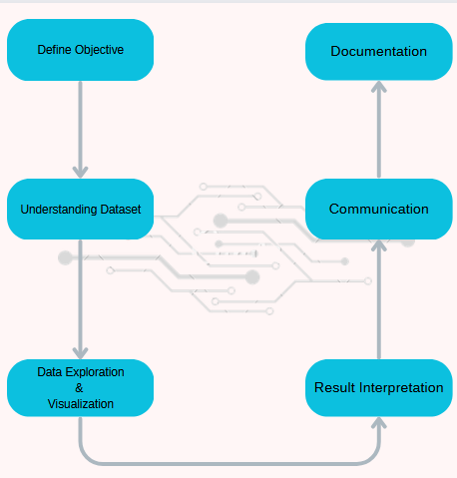

|  |  |  |  |  |  |  |  |  |  |  |  |  |  |  |  |  |  |  |  |  |  |  |  |  |  |  |  |  |  |  |
| --- | --- | --- | --- | --- | --- | --- | --- | --- | --- | --- | --- | --- | --- | --- | --- | --- | --- | --- | --- | --- | --- | --- | --- | --- | --- | --- | --- | --- | --- | --- |
| **User Stories** | **Data** |  | | |  | | Accessing Resource | USN-1 |  | **As a Data Analyst, I** | | | | | | |  | | |  | Successfully | | | | |  |  | | High | Cindurasri |
| **want to collect relevant** | | | | | | | | |  | collect data | | | | | |
| **Analyst** | |  | |
| **data from a variety of** | | | | | | | |  | | from 100 top | | | | | |
|  | | **sources, such as** | | | |  | | | |
| YouTube | | |  | | |
| **YouTube Analytics and** | | | | | | | | |  |
| channels, | | |
| **third-party tools, to** | | | | | | |  | |
| covering | |  |
| **compile a** |  | | | | | |
| **comprehensive dataset** | | | | | | | | |  | |
| **of the top YouTube** | | | | | | |  | |
| **channels, so that I can** | | | | | | | | |
| **perform an in-depth** | | | | | | | |  |
| **analysis of their** | | | |  | | | |
| **performance and** | | | | |  | | |
| **audience engagement** | | | | | | | |
|  | | | | | | | |
|  | **Content** | | |  |  | | analyzing | USN-2 |  | **As a Content Analyst,** | | | | | | | | | |  | Analyze | |  | | | |  | | High | Anisha Priyadarshini R |
| **I need to analyze the** | | | | | | | | |  | content | |
| **Analyst** | |  |
| **content of top** | | | |  | | | | | | from 20 | |
|  | |
| **YouTube channels,** | | | | | | | |  | | top |  |
| **identifying emerging** | | | | | | | | | | Iphone versions | | |  | | |
| **trends and** | |  | | | | | | | | , | | |
| **engagement** | | |  | | | | | | | identifying | | | |  | |
| **strategies, in order to** | | | | | | | | | |
| five |  | | |
| **provide insights to** | | | | | | | |  | |
| emerging | | |  |
| **content creators and** | | | | | | | | |  |
| trends . | |  |
| **marketers on how to** | | | | | | | | |  |
|  | |
| **improve their** | | | |  | | | | | |
| **content and audience** | | | | | | | | | |
| **interaction.** | |  | | | | | | | |
|  | **Audience** | | | |  | | Research based on audience | USN-3 | I want to be able to input patient data, including demographics, medical history, and current condition, into the system for accurate estimation and prediction of hospitalization and medical care costs. | | | | | | | | | | |  | Conduct | | |  | | |  | | Low | Cheryll Evangeline Stephen |
| **Research** | | | | **er** |  | surveys with | | | | |  |
| 500 viewers of | | | | | |  |  |
|  | | | |  |
| top YouTube | | | | |  |  |
| channel | | s | | |
|  | |
|  | **Project** | |  | |  | | Managing data | USN-4 |  | As a Project Manager, | | | | | | | | |  |  | Develop and | | | | |  |  | | Medium | Dasari Swetha |
| **Manager** | | |  | my role is to oversee | | | | | | | | , | maintain a | | | |  |
|  | | | the project, ensure | | | | | | |  | project plan, | | | | |
| that it stays on track | | | | | | | |
| manage | |  | | |
| manage resource | | | | | |  | |
| resource | | |  | |
| allocation, and | | | |  | |
| communicate with | | | | | | |  | Allocation. | | | |  |
| stakeholders. | | | | | | | | |  | |  | |